**BANK CUSTOMER CHURN ANALYSIS**

1. **BRD Documents**

**2. Data Gathering**

**3. Data cleaning / Data Transformation**

**Objective:** To analyse the Bank departure data set and give insights on what leads to the departure of customers.

**Data Description :**

There are 10,000 rows and 14 columns which are as per below.

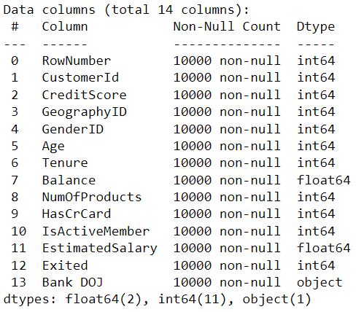

There are no duplicate values or missing values found in the data.

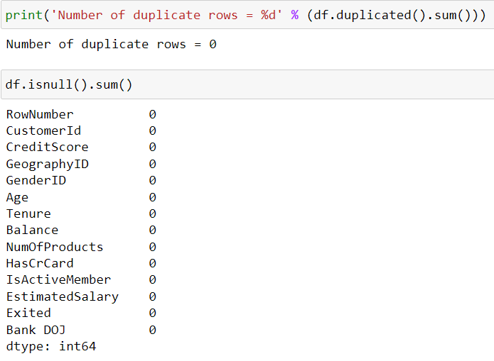

There are some discrepancies in the data, one that is observed while scanning the csv file was that there are some unnecessary punctuation marks in the customer info file which needs to be removed.

1. **Data Modeling**

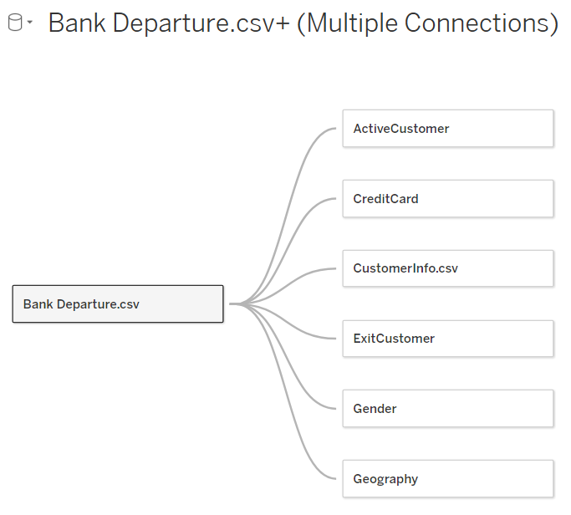

1. **UI (Tableau view Reports)**

7 different views were created with 7 KPI, 6 global filters , 2 bar graphs, 1 line graph, 1 pie chart and 1 donut chart. And putting all these one dashboard was created.

* KPI
  + - Blocker - We see that the “Active customer” KPI is in block letters and it is not changing to normal.
      * Solution - In the dashboard click on “Active customer” then format -> Fields->sum(Active customer)-> change the Font
* Filters
  + - Blocker - We created 6 global filters and one filter for a particular sheet but it is observed that it is being applied to whole workbook which is not getting fixed.
      * Solution- removed that filter from all other sheet. It was present there by mistake.
* Total customer by active category bar graph.
* Exit customer of current year vs previous year comparison line graph.
  + - Blocker-We created a parameter “current year” and used it in the calculated field “Crt yr prev yr” and used it as a filter for that sheet only, but it is being applied in the entire workbook.
      * Solution - Removed the filter from all other sheets
    - Blocker- Making the legends dynamic to show the current year value.
      * Solution- used parameter instead of plain text in the calculated field.
    - Blocker- With changing legend names, the color is not constant but changing as well.
      * Solution- created a calculated field named color such as if INT([Current year])=YEAR([Bank DOJ]) THEN 'Blue' ELSEIF INT([Current year])-1=YEAR([Bank DOJ]) THEN 'Violet' ELSE "Neither" END and took a separate sheet , dragged crt yr prev yr calculated field to columns and the color calculated field to colors
* Exit customer with credit type bar graph
* Exit customer with credit card holder category pie chart.
* Exit customer by gender category donut chart.
  + - Blocker- When applying gender filter, the donut chart is showing 100% of that gender.
      * Solution- used fixed LOD and created a calculated field and put it in label and angle and changed formatting of numbers to percentage.
* Dashboard
  + - Blocker- In the dashboard the filters are not coming under the KPI container. Legends are overlapping in presentation mode.
      * Solution- Click any graph, then go to analysis, click on filters, then select the filter you want to bring, then make it floating and then click on it+shift and put it in the container.
      * Solution- Use Blanks while creating containers.
    - Blocker 2- There are few gaps between the containers.
      * Solution - Remove the padding
    - The filters are not fitting the entire view.

1. **Tableau functions**

Functions used were IF,COUNT, SUM ,

Fixed LOD was used.

We used a parameter named “current year” to create the line graph for month wise current year vs previous year customer exit comparison.

7. Enhance UI

8. RLS (Row Level security)

9. Create Project space in Tableau Server and provide the access

10. Publish the report to the Project space on Tableau Server

11. Dashboard/Mobile view

12. Schedule a Refresh

13. Add roles to Security

14. Subscribe, manage alert Share the reports

1. **Learnings** 
   1. Dashboard layout using tiled containers.Creating containers inside containers to keep the legends. Checking out the item hierarchy.Removing the sub parent containers to improve performance.
   2. Creating dynamic legends
   3. Unit testing of donut chart
   4. Using fixed LOD
   5. Putting the filters inside the containers.
   6. context filters - reduces performance, when you create a context filter it creates a temporary data set. Hence 4 to 5 context filters can be used in a dashboard not more than that.
   7. Go for sets and not groups.